Table of Contents
ABSTRACT 3
Introduction 4
Demand and supply analysis 5
Econometric Model 12
Scatter Plots 12
The line of Regression 14
Regression Line Equation 16
Excel Worksheet of the Regression Analysis: Apple Inc. 19
Elasticity 20
Transcript of Apple iPad Elasticity Analysis 20
Income Elasticity of Demand 20
Product Elasticity 20
Pricing Analysis 21
Hypothetical Analysis 22
Forecasting 23
Equities 23
Consented Recommendation 23
Share price forecast 24
Dividends 24
Earnings History & estimates 25
Historical Revennue & estimatations 25
Marginal Analysis 26
Apple Inc., Smartwatch Economic Analysis 28
References 30

Abstract
Apparently, this is the case study of Apple Company based on the five tools used to solve strategic management problems. They are supply and demand, regression analysis, elasticity, forecasting and marginal analysis. This is a strategic management tool that looks to boost performance, build clientele and out compete for rivals in the chosen market. Demand and supply can be calculated using linear functions to which we use some variables as slope parameters to give a statistically accurate estimate of what the demand and supply for a product are within a particular market. In turn, this allows an economist to calculate equilibrium, increasing a company’s efficiency. This increase in efficiency is vital to boosting the performance of the company, which aids in solving the problem of increasing sales into 2018. Regression analysis is another tool which is the technique used to determine how one or more explanatory variable affect the value of a regressand. In the case of this project, the regressand is sales, and the explanatory variable may be income.
The regression analysis can be broken down into five components of simple regression, multiple regression and interpreting the P, F and T values produced from the data analysis from the gathered data on the regressors from the quantity demanded and supplied function. The third component to utilize is elasticity calculations which will enable the economist to calculate the change in demand or supply with a decrease or increase in the price of the product which directly correlates to increasing sales. Marginal analysis is the fourth tool and will focus on experimenting with the choice variables by small amounts to see if the objective (increased sales) can be further increased due to the fact this is a maximization problem. The final tool in solving the issue of decreased sales will rely heavily on qualitative data such as an expert opinion on the movements of the market supported by the evidence provided from the previous four tools.

Introduction
Apple is one of the world's driving purchaser hardware and PC organizations. The Cupertino, California-based organization was built up in 1977 as Apple Computer Inc. It dropped the "PC" from its name in mid-2007 (Khan and Alam, 2015). Apple's present place in the worldwide commercial center is a long ways from its unassuming beginnings, with Steve Jobs, Steve Wozniak and Ronald Wayne offering hand-made PC packs in the late '70s. The organization kept on concentrating on PCs for the next decades, yet as of late that concentration has moved more to customer gadgets, for example, the iPhone, iPad and iPod.
Nevertheless, Apple additionally offers a scope of related programming, administrations and applications, with probably the most unmistakable non-gadgets items being the iCloud, iOS, Mac OS and Apple TV (Sanchirico, 2014). Furthermore, the organization offers and conveys computerized applications and programming through its iTunes Store, App Store, iBookstore and Mac App Store. Apple has stayed concentrated on building up its own equipment, programming, working frameworks and administrations to furnish its clients with the most ideal client encounter. A critical part of the organization's endeavors likewise go toward promoting and publicizing as it accepts such endeavors are basic to the advancement and offer of its item.
Apple Inc. was assessed as the most appreciated association on the sphere since 2008 till 2012 by the magazine Forbes for its progressive mobile, "The iPhone." (Jobs et al., 2015). Apple Inc. is the primary business to achieve much showcase appropriation of the touchscreen with pre-modified signals. Presumed as the second biggest data innovation group, the third largest PDAs producer and the second largest traded on an open market organization on the planet.

Demand and supply analysis

General Demand Function:
Q_{d} = f (P,M,P_{R},T,P_{E},N)

In economics there is a general law of demand and supply. Where, ceteris paribus (holding all factors constant), the price worth of a specific decent or administration increases, then the demand for such high or policy declines. On the off chance that the price diminishes then the likely demand additionally builds (there is an inverse relationship between the variables). In the supply side, if the price of a decent or administration makes, then companies will supply the higher volume in the market of such management. On the off chance that the price diminishes, then companies will cut their supply of the great or authority ( there is a positive relationship between the variables) (Rios et al., 2013). The market then alters the price of the great or policy with a specific end goal to fulfill both the clients and the providers. This is called showcase harmony. In this paper, an examination of the supply and demand for Apple iPhone products is the fundamental course of the discourse (Rachet, 2014).
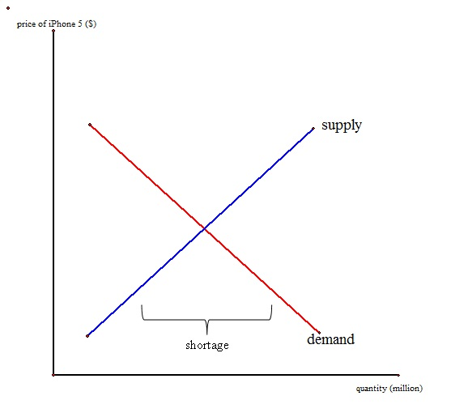
Diagram 1: iPhone 5 launch: Demand and supply Analysis
Given Diagram 1, the amount demanded iPhone 5 exceeds the number delivered by Apple; therefore, there is a lack of supply. Apple can create more arrangements in light of the fact that the sum requested is depended upon to be 10 million units (Rachet, 2014). In case Apple made sense of how to supply 10 million units of iPhone 5 to take mind without limits request from purchasers, Apple can grow its advantage at the adjust point where adequacy happens.

Personally, the issue on the workers strike is not a huge matter to Apple in light of the fact that iPhone has transformed into an essential mobile phone in the market, especially in the U.S publicize (Rachet, 2014). Why do numerous people pick iPhone over various cell phones? The major attributions to this are the item quality, cost, and brand. iPhone is highlighted with widescreen sort out that enables its customers to watch recordings and touch the screen rapidly. iPhone moreover continues running on the iOS which is a working system that gives a critical number of uses (Tan and Carrillo, 2016). While numerous Android phones form into the market, still many telephone customers assume that iOS applications be the best. Given the iPhone 5's business desire, unmistakably customers will pay a high price for iPhone. It is a value purchasing telephone due to its high caliber.
Apparently, along these lines, Apple can charge a higher cost for its iPhone and along these lines makes more vital general income. iPhone also has been a solid brand in the overall market. People buy iPhone as an adult toy. For example, iPhone customers are perceived as a rich people or potentially a 'tech geek.' (Tan and Carrillo, 2016). Every one of these zones have isolated iPhone from its close-by substitute, yet not a superb substitute. iPhone fans, for instance, will pay more for iPhone. Along these lines, when its value augment, the sum requested iPhone reduces yet it doesn't mean truly reduction to zero unless the cost rises by adequately inconceivable totals (Rachet, 2014). Right when buyers change to its substitutes, the request twist for iPhone will move to the other side, however not greatly gigantic i.e. lessen sought after. Given Diagram 2, as buyers swing to elective phones, the request bend D1 Move to D2.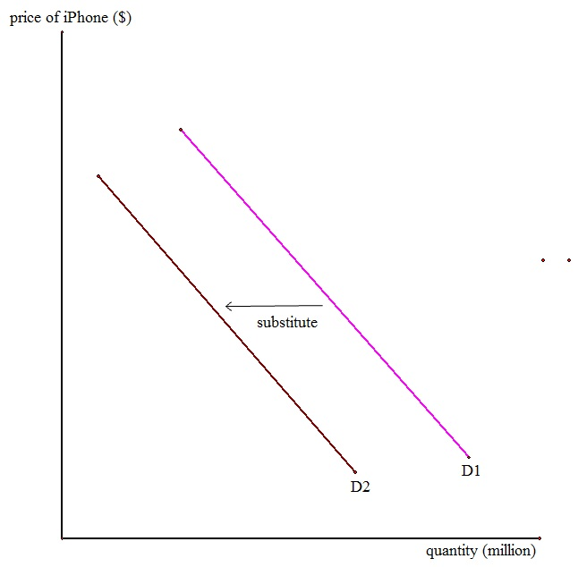
Diagram 2: the effect of Substitution
As iPhone has the item separation over its adversaries who continue running on Android systems for their phones, Apple can make high arrangements. Since iPhone is in monopolistic contention, iPhone makes a short-run yield and value decision essentially like a controlling framework firm does.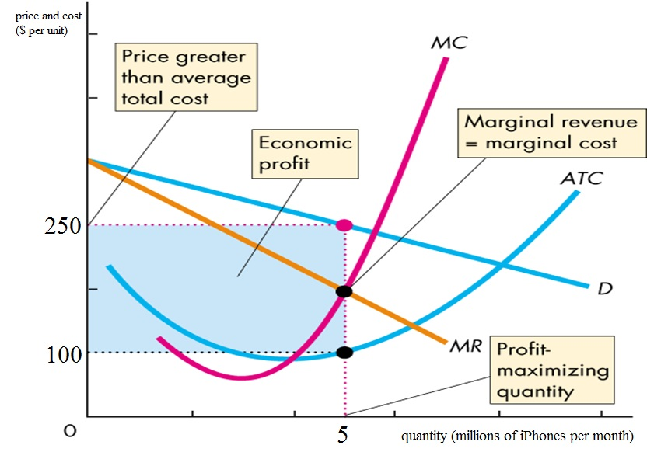
Diagram 3: Economic profit in the Short run
Apple augments benefit by delivering the amount at which negligible income breaks even with minor cost, a huge number of iPhone a month and charging the price of 250 USD per unit. This number surpasses the typical aggregate cost of 100 USD per unit. The blue rectangle delineates financial benefit of 750 USD million every month. (Allude to Diagram 3).
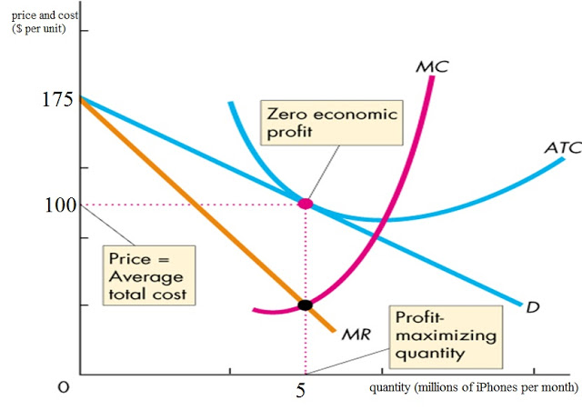
Diagram 4: Zero economic Profit in the Long-run.
In any case, iPhone is not profitable to increase monetary yield for long. Inevitably, its rivals and new companies join the cell phone advertise as iPhone creates a financial profit. As a result, the demand for iPhone diminishes as more companies enter the marketplace (Tan & Carrillo, 2016).. The demand bend and peripheral income move leftward. In this manner, the profit boosting amount and price fall. At the benefit augmentation, the price change measures up to standard aggregate cost, so monetary profit is zero (Rachet, 2014). With the end goal for iPhone to recapture profit in short run, Apple needs to dispatch new telephone to begin the cycle once more.

Relatively, this infers that Apple would require to outline a fresh phone that far prevalent isolated so Apple can battle in the market with more necessary arrangements volume. This circumstance can be seen when Apple propelled iPhone 5 after iPhone 4S has been in the market for a year in light of different cell phones like Samsung Galaxy enters the market. (Allude to Diagram 4). To wrap things up, I trust that everybody realizes that iPhone has been sensational to the worldwide market. Demand for iPhone is growing for each prototype propelled. The accomplishment of Apple iPhone in the telephone market is taking its energy to impact the market for cell phones. Any potential dangers and negative hypotheses appear not to upset Apple gravely. Apple without a doubt is a market driving for mobile phones (Tan & Carrillo, 2016).

Econometric Model

Scatter Plots
As shown by the movement, one of the initial phases in relapse is to plan your information on a disseminate plot (Kenett et al. 2014). The accompanying table records the month to month deals and publicizing consumptions for all of a year ago by an advanced hardware organization.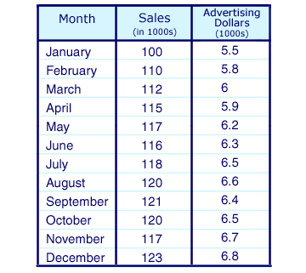
For this situation, you would plot a year ago's information for a month to month deals and promoting uses as appeared on the thin plot underneath. (Information for independent and ward factors must be from a similar timeframe.)
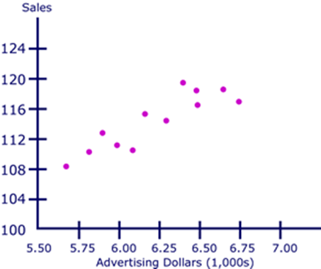
Scatter plots are viable in outwardly recognizing connections between elements. These connections can be communicated numerically regarding R^2 (coefficient of correlation), which is usually alluded to as a relationship. Correlations are records of the quality of the link amid two factors. They could be in whichever incentive from between –1 and +1. (Grasa, 2013).
Consequently, once you use relapse to predict forthcoming estimations of the penniless variable, the ideal relationship between the free and ward variable is high in through and through regard terms, some place in the range amid .5 and.99. Seeing the thin plan overhead, one could see that there appears, all in all, to be some level of relationship among the level of advancing utilization and item care. At whatever point figured, this connection measures up to .89. This recorded data will engage you to predict the association between the two components later on before any further cost is obtained. With a particular ultimate objective to make these desires, a relapse line must be drawn from the information appearing in the scatter plot (Grasa, 2013).

The line of Regression
The diagram beneath is similar to the scatter plot overhead, as well as the line of regression fixed to the figures that are historical.
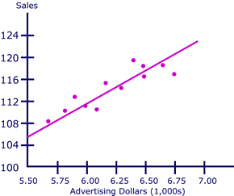
The line of regression is the one with the littlest conceivable arrangement of separations amongst itself and every information point (Grasa, 2013). As should be obvious, the regression line touches a few information focuses, however not the rest. The separations of the information focus on the line of regression are called stochastic terms.
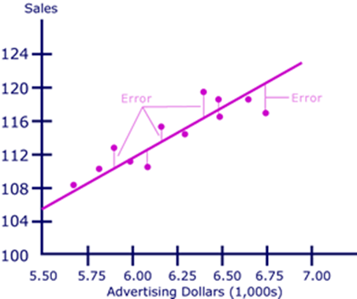
The line of regression will dependably comprise of stochastic terms since, as a general rule, independent factors are never flawless indicators of the reliant factors. There are numerous wild figures the commercial world (Grasa, 2013).The stochastic term be real since a regression model could not once incorporate every conceivable variable; some prescient limit will dependably be missing, especially in basic recession.
The normal process for discovering the best fit line is known as the minimum squares technique. This count is typically completed utilizing PC programming. In this count, the best fit is found by captivating the distinction amongst the line and each and every information point, squaring every distinction, and including the qualities collectively (Grasa, 2013). The minimum squares technique depends on the rule that the entirety of the squared errors ought to be made as little as conceivable, so the line of regression has the slightest error.
When this line is resolved, it can be stretched out past the chronicled information to foresee upcoming levels of produce mindfulness, with a specific level of publicizing consumption.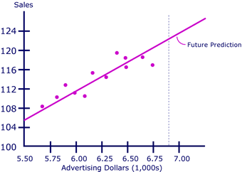

The expansion of the line of regression needs the presumption that the primary procedure bringing about the connection between the two factors is substantial past the scope of the specimen information (Grasa, 2013).. Regression is an active business apparatus because of its capacity to foresee future relationships between elements, for example, these.

Regression Line Equation
Variables, constants, and coefficients are represented in the equation of a line as
• X accounts for the regressor
• F(x) accounts for the regressand
• the constant b symbolizes the y-intercept-this will be the worth of the regressand if the regressor is equal to zero
• the coefficient m defines the shift in the regressand as a result of a given change in the regressor
In finance, straight regressions are regularly used to portray the profits of an separate security (subordinate variable) contrasted with the benefits of the market when all is said in done (regressor) (Grasa, 2013). The condition for the significant direct regressions used to depict security developments is additionally a straightforward line and is communicated in a configuration, which, while comparable, contains several turns.

The equation beneath is a relapse equation for a straight line portraying the connection between the profits of security I and the market when all is said in done.

• ri symbolizes the yield of security I and is the regressand
• r_{m} symbolizes the overall yield of the market and is the regressor
• b is the slope of the regression line, and it describes the level of movement in security I as a result of a unit of movement in the market, in general,
• a is the y-intercept of the regression line
• I am an stochastic term that defines the distance between an actual data point and the corresponding point on the regression line
The diagram underneath gives a graphic portrayal of this line of regression. The profits of the market, all in all, are spoken to in this chart by the profits of the S&P 500. 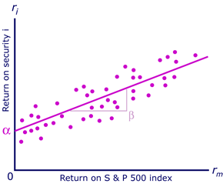

There may be familiar with talks in money related circles about the beta (b) of security being a measure of the security's risk. The hazard activity of beta is figured using relapse strategies. Beta, the slope of the relapse line, was delineated above as the level of advancement in the benefits of a given security for each unit of improvement in the market when all is said in done (Grasa, 2013). A wellbeing with a high beta is seen as dangerous and will experience colossal swings in its benefits when appeared differently in relation to those of the market. A security with a low beta is considered as less risky and will have gives back that shift not precisely those of the market. The alpha term (an) in the relapse state of a security addresses the security's slant to move self-governing of the market. The alpha and beta of a security can't be observed clearly yet are evaluated, given the past execution of security, through relapse examination (Grasa, 2013).

Excel Worksheet of the Regression Analysis: Apple Inc.
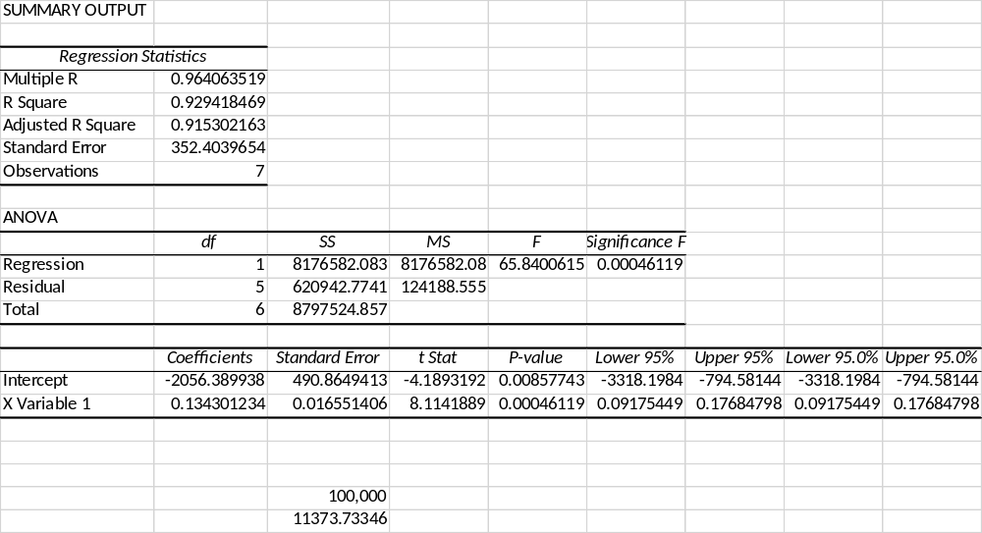

Elasticity

Transcript of Apple iPad Elasticity Analysis
16 GB: -2.09
32 GB: -1.93
54 GB: -1.99
Price Elasticity of Demand: Apple iPad Elasticity Analysis
The percentage change of the quantity demanded would exceed the percentage change in price.
It means that (Zhang et al. 2016): If Apple drops the price, the revenue is likely to rise due to higher demand.
If Apple increases the price, the revenue will reduce because of a much lesser demand.
For example +1.6 average for all models of iPad.
Income Elasticity of Demand
1) the number, being more than one implies that consumers' incomes significantly influence the demand for the product.
2) It is a luxury product and is revenue elastic
3) a rise in revenue means that a customer is expected to purchase more amounts of the product.

Product Elasticity
The past specified financial evaluating plan is related the Game-Theory idea that is utilized to decide an ideal approach to exceed their adversary. It is finished by embracing low-to-high or high-to-low price methodology that will keep their adversary speculating that is most appropriate to the market a particular period (Song, 2015). It ought to likewise be noticed that the oligopolies' demand bends will rely on upon how each opponent responds to the valuing changes by either party.
Essentially, oligopolistic endeavors will regularly arrange the fighting value diminish that falls underneath the "going cost" since it will undermine their fundamental cost and along these lines do their customers switch items (Song, 2015). Regardless, they will slight any cost augment that is over the "going cost" on the grounds that the foes' assessing increment methodologies would every now and again provoke business hardships. Since their value help that was over the client's value wants. By then, it is sensible to express that most oligopolists will demonstrate non-deceitful value direct that is known as the pleated request twist. This request bend is consistently portrayed as an incredibly flexible request when it is over the going cost, yet it is inelastic when falling underneath the going value (McConnell et al., 2009).

Pricing Analysis

Subsequently, kinked-demand curve has set up a see assignment that modifications in the item cost will negative effect on the customer obtaining wishes and will incite benefit lift to enemies that don't oblige the esteeming arrangement underneath the going cost. By then, it is insightful to acknowledge that a value cut will manufacture the total wage yet the oligopolists' total costs may have increase. Since the supply total will depend on upon how request flexibility adjust the buyer's slant at a given time of offers (McConnell et al., 2009). Likewise, "a cost decrease in the inelastic territory cuts down the organization's total wage, and the creation of a greater yield constructs its total costs" (McConnell et al., p.236, 2009). Thusly, oligopolists' creation cycle the cost must outperform negligible cost and standard total cost.

Regardless, if generation is underneath the yield in which it could constrain the standard total cost. By then, it is protected to acknowledge that neither the profitable adequacy which creation must be equal nor least normal aggregate expenses. It additionally can't rely on upon the allocative efficiency approach that states production must equivalent peripheral cost. (McConnell et al., 2009).

Hypothetical Analysis
The theoretical analysis was to figure out what changes in the settled and variable expenses could influence the business operation fetched for the single unit by utilizing short-run production costs. With a specific end goal to along these lines, the settled and variable expenses were gotten from the iPhone 5 production prepare. This product was priced at 650 USD which included assembling cost 226.85 USD and effective cost of 61.18 USD, and after that discount markup of 68.90 USD (Sherman, 2013). Next, the aluminum smartwatch was just utilized as a part of this theory and its stainless steel mark 549 USD and 599 USD price go with demand curve of 0.09 % (=50 USD/549 USD). At that point, the assessed 15 million for each unit from the aggregate at the most astounding cost of this model will be acquainted with a 50 USD discount with increment mark consciousness of this sort and to avert match passage into the market (Sherman, 2013).

Forecasting

Equities
Price (USD):143.65
Today's Change: -0.14 / -0.10%
Shares Traded: 20.86m
1 Year Change: 51.48%
Beta: 1.1642
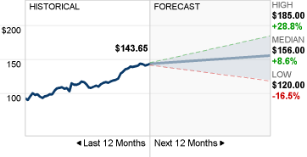

Consented Recommendation
As of Apr 24, 2017, the consensus forecast amongst 52 polled investment analysts covering Apple Inc. advises that the company will outperform the market. This has been the consensus forecast since the sentiment of investment analysts deteriorated on Oct 17, 2011. The previous consensus forecast advised investors to purchase equity in Apple Inc (Konchitchki & Patatoukas, 2016).
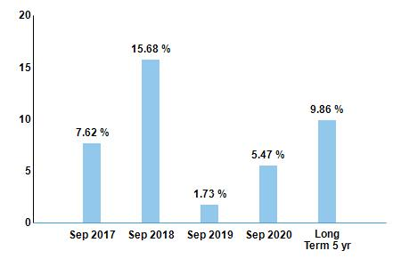

Share price forecast
The 41 experts offering 12-month price focuses for Apple Inc. have a central focus of 155.00, with a high gauge of 180.00 and a low gauge of 104.00. The middle gauge speaks to a 7.90% expansion from the last price of 143.65 (Konchitchki & Patatoukas, 2016)..

Dividends
In 2016, Apple Inc detailed a profit of 2.18 USD, which speaks to a 10.10% increase over a year ago. The 18 investigators covering the organization expect earnings of 2.32 USD for the up and coming financial year, an increase of 6.28% (Konchitchki & Patatoukas, 2016).
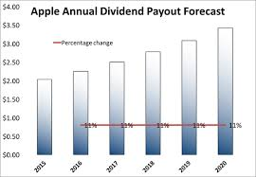

Earnings History & estimates
On Jan 31, 2017, Apple Inc. detailed first quarter 2017 profit of 3.36 for each share. This outcome was by the agreement of the 36 investigators taking after the organization and surpassed a year ago's the first quarter comes about by 2.44%. The following income declaration is standard on May 02, 2017.

Historical Revennue & estimatations
Apple Inc. had 1st quarter 2017 revenues of 78.35bn. This bettered the 77.28bn consensus of the 35 analysts covering the company. This was 3.27% above the prior year's 1st quarter results.
Apple Inc. had revenues for the full year 2016 of 215.64bn. This was 7.73% below the prior year's results (Konchitchki & Patatoukas, 2016).
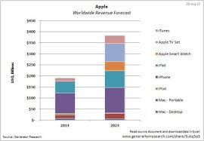

Marginal Analysis
On the off chance that you purchase an iPhone 6 or more rather than the littler iPhone 6, Apple makes an additional 84.50 USD in profit on the telephone, as per Bloomberg, referring to an assembling cost breakdown by the exploration frame IHS. Another parts examination, from Teardown.com, discovered something comparative: The bigger screen and battery in the iPhone 6 Plus. Additionally, is a couple of other more negligible costs, add 15.50 USD to the cost of making an iPhone 6 Plus. However, Apple is energizing to 100 USD more for the bigger telephone. (Coughlin, 2016). 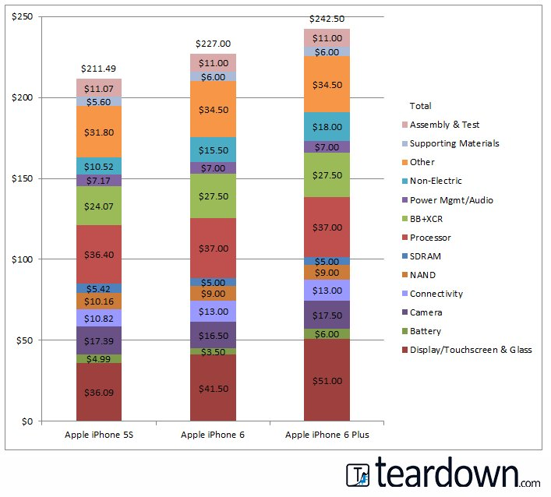

Here is the IHS breakdown chart:
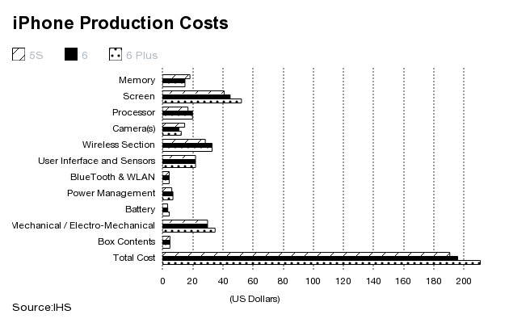
Teardown.com says the two aspects of iPhone 6 Plus that increase its manufacturing costs are the screen and the battery. The larger screen on iPhone 6 Plus costs 9.50 USD more, bringing the total screen cost to 51 USD, and the larger battery is 2.50 USD more, paying that cost to 6 USD. (Coughlin, 2016). The overall effect on Apple's first profit after manufacturing costs alone is significant. That would mean first profit on an iPhone 6 is about 73% of the 849 USDprice (619.77 USD). On iPhone 6 Plus it's 75% of 949 USD (or $711.75). We got those numbers in part from Re/code (Coughlin, 2016). Remember, this is before all the other costs that Apple must bear, like sales and marketing, staff, and distribution costs. So these numbers are somewhat misleading.

In any case, they are intriguing because they demonstrate that paying little respect to how you compute the two arrangements of assembling costs, Apple will profit on iPhone 6 Plus given its size then it will on iPhone 6.Now include the way Apple has organized estimating for the different stockpiling levels inside the telephones. As we let you know beforehand, iPhone 6 models accompanied 16 GB, 64 GB, and 128 GB of capacity (rather than the 16 GB, 32 GB, and 64 GB of earlier models) (Jobs et al., 2015). No one will pick 16GB on the off chance that they can help it - it's much too little a sum for an advanced cell phone. So a considerable measure of clients will pay an additional $100 for the higher range stockpiling — adding a cluster more cash to Apple's margins. This is all excellent news for Apple's shareholders — it demonstrates CEO Tim Cook is keeping up the organization's large profit margins and adding to the 13 USD billion heap of money it continues its financial record (Jobs et al., 2015)..

Apple Inc., Smartwatch Economic Analysis
This business proposition methodology will concentrate on an inventive organization that produces propelled innovation products for versatile gadget clients in the worldwide market. The venture plan will address the common and nearby monetary condition for this supplier. It additionally will inspect the business cycle and its FICO score conditions (Jaswal et al., 2016) Next, it will distinguish the market structure, and the elasticity of the product by measuring the evaluating and non-pricing systems towards its settled and variable expenses to decide marginal costs and limited income of the production per unit (Madigan, 2015). In conclusion, it will look at how those monetary components could influence the supplier's price and operation choices for the products or administration in the picked target portion, for example, Texas.

In the previous two decades, Apple Inc. has turned into the world number one imaginative organization of innovative compact gadgets that have been adequately outlined and propelled to meet buyer's inclination. Its gadgets had contributed the organization's market capitalization worth estimation more than 650 billion of combined income for its 30 years of presence in the retail, commercial center (Jaswal et al., 2016). On March 10, 2015, it reported a smart watch gadget that will have 18 hours of battery life to maintain its execution in any work as well as play condition (Arnold, 2014). Additionally, the product advertising position is one of comfort that will make less demanding for the purchaser to interface with their gadgets. For example, it will enable them to send and get messages or telephone brings in a valuable way (Olivarez-Giles, 2015).

References
Arnold, N. (2014, December 21). Apple's 7 Most Innovative Device through the Years. Retrieved from Cheat sheet: http://www.cheatsheet.com/stocks/apples-product-timeline-the-best-of-the-best.html
Coughlin, T. (2016). Apple, Inc. v. Samsung Electronics Co.: Economics of Design Patent Trolling. Cardozo Arts & Ent. LJ, 35, 209.
Grant, R. M. (2016). Contemporary strategy analysis: Text and cases edition. John Wiley & Sons.
Grasa, A. A. (2013). Econometric model selection: A new approach (Vol. 16). Springer Science & Business Media.
Jaswal, R., Novo, J., Ponton, A., Smith, K., & Tan, D. (2016). Section D200 Strategic Analysis for: BlackBerry Ltd.
Jobs, S., Mantia Jr, L. D., Bachman, W. M., & Robbin, J. L. (2015). U.S. Patent No. D720,773. Washington, DC: U.S. Patent and Trademark Office.
Kenett, D. Y., Huang, X., Vodenska, I., Havlin, S., & Stanley, H. E. (2015). Partial correlation analysis: Applications for financial markets. Quantitative Finance, 15(4), 569-578.
Khan, U. A., Alam, M. N., & Alam, S. (2015). A Critical Analysis of Internal and External Environment of Apple Inc. International Journal of Economics, Commerce and Management, 3(6), 955-961.
Konchitchki, Y., & Patatoukas, P. N. (2016). From forecasting to now casting the macro economy: A granular-origins approach using financial accounting data. Review of Accounting Studies.
Madigan, K. (Jan, 2015). Economic News Coverage on Oil Prices Turns Negative, Wall Street Journal.
McConnell, C. R., Brue, S. L., & Flynn, S. M. (2009). Economics: Principles, problems, and policies (18th Ed.). Boston, MA: McGraw-Hill Irwin.
Olivarez-Giles, N. (2015). Battery Worries on Apple Watch. Wall Street Journal, B4.
Rachet, B. (2014). Swot Analysis of Apple Inc. Docs. school Publications.
Rios, M. C., McConnell, C. R., & Brue, S. L. (2013). Economics: Principles, problems, and policies. McGraw-Hill.
Sanchirico, C. W. (2014). As American as Apple Inc.: International tax and ownership nationality. Tax L. Rev., 68, 207.
Sherman, J. (2013). Spendy but indispensable: Breaking down the full $650 cost of the IPhone 5. Digital Trends, 1-5.
Song, M. (2015). A hybrid discrete choice model of differentiated product demand with an application to personal computers. International Economic Review, 56(1), 265-301.
Tan, Y. R., & Carrillo, J. E. (2016). Strategic analysis of the agency model for digital goods. Production and Operations Management.
Zhang, Z., Tao, Y., Drzaic, P. S., & Wurzel, J. G. (2016). U.S. Patent Application No. 14/987,129.

